UPPER SKILLS CAREER DEVELOPMENT EVENT RULES AND REGULATIONS
2023-2024 School Year Please Read These Rules Carefully!!

General

- All advisors present shall serve as judges in some capacity at the West TN Skills CDE. At least two judges per skill/activity during the contest. As an advisor, it is your job to communicate with skills committee what you are comfortable or not comfortable judging the day of the contest. All advisors are expected to judge and work the event.

- No alternatives for the Upper Skills CDE effective immediately.

- Teachers with teams are to remain out of the contest area while contestants are participating in the CDE except host advisor. During the judging, teachers and contestants shall clear the area. Violators shall be disqualified in this skill.

- ALL variances in welding, wiring, rafters/truss will be determined by the skill judgers on site the day of the contest. This will not be pre-determined before arriving to Haywood County High School.

- The skills will not be announced until students have reached designated area of skill in the shop or classroom.

- Judges shall arrive at CDE site at 1:00pm (30 minutes early) to survey working facilities in advance of the CDE and to arrange adequate working space. The CDE will begin promptly at 1:30pm. Advisors shall register all contestants one week prior to the CDE on http://westtn.ffanow.org and then check team members in, making any corrections, the day of the CDE. There will be a meeting of judges with CDE chairman and advisors to review the rules of each skill prior to the CDE.

- Judges shall eliminate all ties before reporting final placing. Chairman of the judges is responsible for breaking team ties as follows: “In breaking ties in the skills CDE, the team that finished with the most firsts shall win; this procedure shall continue until a winner is decided. If teams remain tied, the team that places highest in welding in the upper division and the team that places highest in stud assembly shall be the winner.

- No results shall be announced or posted until all results have been turned in to the chairman of the judges.

- Judges shall be available to discuss placing after individual skill results have been turned in to the chairman of judges.

- The West Tennessee CDE shall be held at Haywood High School.

- All upper division skills time limits will be 1 hour and 15 minutes. All work should be turned in at the time limit. Uncompleted work should be placed below completed work. Any skills not completed according to diagrams will place below those who complete their skills accordingly.

- Prior to beginning the CDE, the chairman of the judges shall conduct a drawing to determine which skill each contestant will compete in. Contestants from each school will be listed with consecutive numbers beginning with number one. The four skills will be written on identical slips of paper and folded. With land leveling and land measuring the skill shall be written on two slips of paper. The chairman of the judges shall draw one skill and all contestants with the number one shall perform that skill. The skill will not be announced until that group is dismissed to the skill area. A second skill will be drawn and all contestants with the number two shall perform that skill. The procedure will continue until all skills have been drawn. In the case of land leveling or land measuring where two members will compete, the team will be those numbers drawn at random as is with the rest of the skill areas. These contestants may or may not be consecutive on the list of alphabetically listed students. The same procedure shall be used for both upper and lower division.

- No reference material including notes, rules, tables, or programmable calculators shall be available to the contestants at the site of the CDE unless specified in individual skill rules. If a student is caught using a cell phone during a CDE, he/she will be disqualified from the event. A programmable calculator will lead to disqualification from skill it is used in.

The projected skills for 2023-24 in the upper division are: 1. Wire-Fed Welding (1 person)
- Differential Land Leveling (2 people)
- Three Way Switch (1 person)
4. Rafter Cutting (1 person)

- The skill areas in the upper division for the 2024-25 school year will be:

Arc Welding (1 person)
  - Profile Leveling (2 people)
  - Switch and Receptacle (1 person)
  - Truss Assembly (1 person)

- All judges will discuss with the Chairman of the judges how their event will be conducted, before starting the skill event. The judge should be notified if student is missing materials to complete skill and provide item is available.

- If a team does not have a student representative in a skill area, or if the student in the skill area gets disqualified from the event, the team score for the event will be last place minus one placing. Ex: If a team does not have a student for electrical wiring and 5 teams are registered for the CDE, the team score for that event will be 6th (5th place – one placing).
- All judges in all skill areas will check all supplies before the student begins.

UPPER SKILLS CDE RULES 2022-2023

DIFFERENTIAL LEVELING (Determining differences in elevation)

- Two contestants shall furnish all equipment necessary.
- A three- or four-screw Bostrom level or one of equal quality and magnifying power shall be used.
(No greater than 20x). A self-leveling instrument is not acceptable.
- The differences in elevation must be reported in feet and hundredths of feet. Feet and inches are not acceptable. It will not be necessary to report the difference as a positive or negative number.
- The judge shall designate starting and ending points of permanent bench marks such as concrete steps, walks, fire hydrants, etc.
- Points shall be so located that a minimum of three instrument settings and two turning points shall be made.
- A standard field record report form shall be used by all contestants and turned in to the judge. (Reference: “Elementary Soil and Water Engineering.” Schwab et al, John Wiley and Sons, Inc.) Sample reporting forms and explanation are attached. The Regional Office shall furnish blank contest forms.
- The official difference in elevation shall be determined by as SCS technician or qualified engineer, using an engineering level, and shall be posted after scores have been tabulated.
- Time limit shall be one hour and 15 minutes.
- Request that SCS technician or engineer run measurement twice (forward and backward) before determining the official measurement.
- The contestants shall be ranked according to accuracy and the contestant who has the nearest answer to the judge will be the winner. Ties will be broken first by the neatness of the field notes.
- Safety glasses are not required for this skills area.
- Items needed for this area:
  - Tripod
  - Level
  - Clear clipboard
  - Non-programmable calculator
  - Writing instrument
  - Rod

Differential Leveling Notes

Contestant No.

Station | BS | HI | FS | Elev
B. M. I | 3.25 |  |  | 100.00
 |  | 103.25
T. P. I | 8.12 |  | 4.80 | 98.45
 |  | 106.57
T. P. II | 0.23 |  | 3.21 | 103.36
 |  | 103.59
T. P. III | 4.01 |  | 6.57 | 97.02
 |  | 101.03
B. M. II |  |  | 8.95 | 92.08

15.61 minus 23.53 = -7.92

Bench Mark II is 7.92 feet lower than Bench Mark I Overhead Sketch of Area:

Difference in Elevation 7.92 feet

TRUSS CONSTRUCTION

- Objective: Cut and nail together one truss.
- End cut on rafter of truss shall be parallel to ridge cut.
- This skill, including nailing, shall be performed by only one contestant.
- Clamps, Blocks or jigs to aid in nailing are prohibited. Only a hammer will be used for nailing. Clamps may be used to secure lumber when sawing.
- Adopted procedure for nailing truss: (See Drawing)
- Contestant shall furnish material “ONLY” (three eight foot long graded 2x4’s, one four foot long 2x4, actual size one and one-half by three and one-half.
- Rise/run, span, and horizontal projection (not overhang) shall be given by judge. Span to be given in whole number of feet only (5 to 8 feet). One of the following pitches shall be used: 4/12, 6/12, or 8/12. Horizontal projection shall be given by judge with a length of 4” to 12”.
- Gussets may be precut and brought to contest. At least three gussets 3 1/2” by 7” and one gusset 6” by 6” cut from 3/8” plywood are needed (see diagram).
- Upright brace shall be positioned so that it is centered on the joist and the upper plumb cuts of the rafters.
- Contestant shall furnish necessary equipment to complete job, including nails and sawhorses if desired.
- Gussets shall be fastened on one side only using 6 penny coated nails. Three nails shall be spaced in each 2x4 gusset in a triangular pattern.
- One 8-penny nail shall be used to fasten the upper plumb cut of each rafter. Also one 8-penny nail shall be used to fasten the joist to each rafter, nailing from underneath the joist into the rafter.
- All cuts must be made with a hand held circular saw or hand saw, no further dressing.
- Judge determines accuracy of cuts and length of boards before truss is nailed together.
- Time limit shall be one hour and 15 minutes.
- Safety glasses must be worn by the contestant. Failure to do so will result in lowering contestant one place.
- A framing square with rafter length per foot of run table may be used.
- No cuts will be allowed following measurement of cut boards by the judge.
- Span, horizontal projection and pitch will be turned into the Chairman of the judges before the event begins.
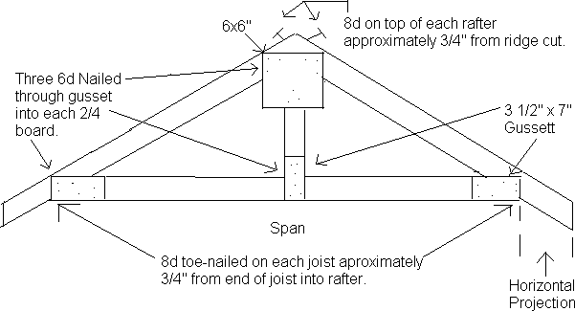

RAFTER CUTTING

- Cut a pair of rafters and nail ridge cut.
- End cut on rafter shall be parallel to ridge cut.
- This skill, including nailing shall be performed by only one contestant.
- Clamps, Blocks or jigs to aid in nailing are prohibited. Only a hammer will be used for nailing. Clamps may be used to secure lumber when sawing.
- Adopted procedure for nailing rafters: (See Drawing)
- Contestant shall bring to contest two 2x4 by 8’ boards or two 2x4 precut studs.
- Rise/run, span, and horizontal projection (not overhang) shall be given by judge. Span to be given in even number of feet of six, eight, or ten feet. One of the following pitches shall be used: 4/12, 6/12, or 8/12. (Reference: Jones-Phipps-Wakeman).
- The bird’s mouth shall be cut at such a depth that two inches shall be left from the bird’s mouth to the top of the rafter. (See drawing)
- Contestant shall furnish other necessary equipment to complete job, including nails and sawhorses if desired.
- All cuts shall be made with saw (hand or power circular saw), no further dressing.
- Judge determines accuracy of cuts and length of rafter before nailing up.
- Time limit shall be one hour and 15 minutes for completion of cuts (time will be flexible during the nailing process)
- Safety glasses must be worn by the contestant. Failure to do so will result in lowering contestant one place.

Contestant No. | 20 Pts.  Appearance | 20 Pts. Length | 20 Pts.  Accuracy of Cuts | 20 Pts. Length of  H. P. | 20 Pts. Nailing |  | Total
1
2
3
4
5
6
7
8
9
10

NOTE:
SCORE CARD

LENGTH OF RAFTER: 2 points for each 1/16” error from ridge cut to bird’s mouth for each rafter.
ACCURACY OF CUTS: 2 points for each 1/16” in squaring cuts and depth of bird’s mouth. LENGTH OF H. P. 2 points for each 1/16” error for each rafter.
NAILING 5 points for each nail to include: (bending, scarring wood, splintering, etc.)

ELECTRIC ARC WELDING

- Host chapter shall furnish AC welding machine and all contestants shall use these machines.
- Contestant shall bring any amount of metal for practice.
- Contestant shall furnish all materials and equipment needed, except welder, to complete skill including eight clean (oil and rust removed) pieces of mild steel 1/4” and at least 1” wide and 6-7” long. Contestants will need 8 pieces of contest metal.
- Contestants will be allowed to bring a base plate to insure a level welding surface. No larger than a 1’ x 1’ square is allowed.
  - Contestant shall make a butt weld, for 2022-2023, welding full length on one side of the metal for butt joint.
- Contestant shall make one of the following welds as determined by the judge. (See drawing attached to Score Card.)
- No grinding permitted before or after welding: jigs and clamps may not be used to position metal. No magnets to be used. No prior marks or lines may be drawn on the metal for aid in layout of the welds.
- No electric buffer - use chipping hammer and wire brush. The contestant must wear safety glasses or face shield (auto helmet). No safety glasses are needed if auto helmet is used.
- Take second two pieces of metal and repeat process.
- Turn in the best of the butt and other weld.
- The E-7018 electrode shall be used in all contests, 1/8” or 5/32” in diameter.
- Contestant shall determine which size rod to be used.
- Judge is required to cut both welds with a saw to inspect penetration.
- Time limit shall be 1 hour and 15 minutes. (15 minutes for practice and 1 hour for contest)
- Tee weld shall be welded with one piece of metal in the vertical position. No clamps, jigs, magnets or props are permitted.
- Rules and squares may be used.
- Judge will randomly assign welding machines (stations).

NOTE: Only one pass permitted on each side.

Reference: Ag. Mechanics Fundamentals and Applications, Cooper, 4th-6th Edition (See attached page for Score Card)

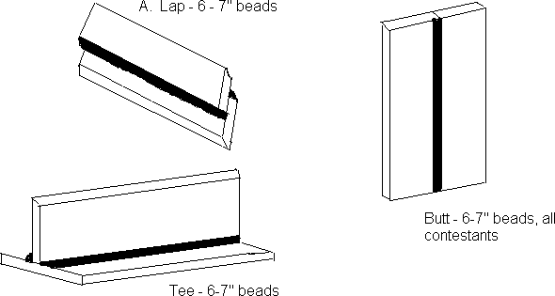

SCORE CARD

- Carrying out correct procedure on page 9 20 points
  - Following rules of CDE
  - Using correct materials, equipment, rods, length of metal, etc.
  - Subtract one point for each degree off 90 degree up to 12 points and one point for each 1/16” off center up to 12 points on the tee weld
  - Subtract one point for each 1/16” off center on the lap weld.

- Strength of welds 50 points
  - Penetration 20 points
    - Weld No. 1 10 points
    - Weld No. 2 10 points
  - Undercutting (more serious than pin hole) 10 points
    - Weld No. 1 5 points
    - Weld No. 2 5 Points
  - Correct length of legs for bead in tee and lap weld 5 points
  - Pin hole and slag inclusion 5 points
  - Cracks in weld 10 points
    - Weld No. 1 5 points
    - Weld No. 2 5 points

    - Smoothness and uniformity of weld 15 points

    - Safety: Removal of glasses will result in loss of points 15 points

ELECTRIC WIRING (SWITCH & RECEPTACLE)

- The three boxes shall be mounted with romex connectors already attached on a plain, unpainted, non- stained board of any type wood prior to contest according to diagram. (See drawing) Failure to follow the preceding rule will result in the contestant ranking being dropped one place.
- Boxes shall be surface mounted with screws.
- All wires shall be above the surface of the board.
- All boxes shall be grounded to the bare ground in the romex; twist wire around screw in receptacle box and switch box too. Ground wire in receptacle boxes should be secured in a horseshoe or ½ moon configuration.
- The three bare grounds in the octagon box shall be twisted together approximately one inch and connected with a crimp-type connector or green grounding wire nut with one ground wire connected to a machine-threaded screw. The ground wires shall be six to eight inches long including the approximately one inch twist.
- Keyless light fixture (plastic or porcelain) shall be connected to neutral and switch wire with No. 14 stranded or solid wire. Six inches to eight inches of free romex and insulated wire shall be left in box after connections are made measured from point of entry.
- All romex must be clamped securely in the boxes.
- All splices, except the ground, shall be twisted together and must be fastened with proper size screw- on type connectors.
- When complete, all switches and receptacles shall be fastened in boxes and covered with metal cover plates.
- The judge will designate the location of the switch and outlet.
- The receptacle and switch will be connected by the eyelets. No question mark shaped eyelets are required. Insulation should stop at screw head and no wire should go past screw head.
- The contestant will not be penalized for bringing extra supplies but may not bring extra wire.
- The white wire leading to the switch may or may not be identified with black tape.
- The contestant must wear safety glasses.
- ¼” to ½” of romex is required inside the box; measured from the romex connector to the end of the romex.
- End of source wire will not be stripped and nothing will be attached to the source wire.
- After judge has made initial inspection, contestant will be asked to remove cover plates and unscrew fixtures from handy box.
- All wiring boards will be tested with an ohm meter for continuity.

SCORE CARD

- Tightness of connections 25 points
- Safety 15 points
- Freedom from injury to wires in stripping, insulating, or twisting.
Insulation should be covering wires 35 points
- Adequate wire in boxes 15 points
- General neatness 10 points

- Contestants not completing exercise will be placed below those who finish the skill. EXAMPLE: See following page:

ELECTRIC WIRING (SWITCH & RECEPTACLE) (continued)

The following materials are necessary to complete the job: (The contestant will not be penalized for bringing extra supplies to the CDE. Contestant cannot bring extra wire.)

  - Two surface-mount outlet boxes. (Sometimes called handy, utility, or conduit boxes)
  - One surface-mount 4” octagon outlet box 1 1/2” to 2” deep.
  - One single-pole toggle switch with ground screw.
  - One grounded duplex receptacle (110V).
  - One surface-mount metal receptacle cover.
  - One surface-mount metal switch cover.
  - One keyless light fixture (plastic or porcelain).
  - One 7-foot piece of unmarked and uncut 12-2 romex with No. 12 ground and two pieces 8” long of No. 14 wire.
  - Five 1/2” romex connectors.
  - Sufficient screws to mount boxes and a machine-threaded grounding screw.
  - One board 1” x 12” x 2’ (approximately). Board may be any type of wood but must not be painted or stained.
  - One small light bulb.
  - Screw-on type connectors of proper size.
  - Crimp-type connector.
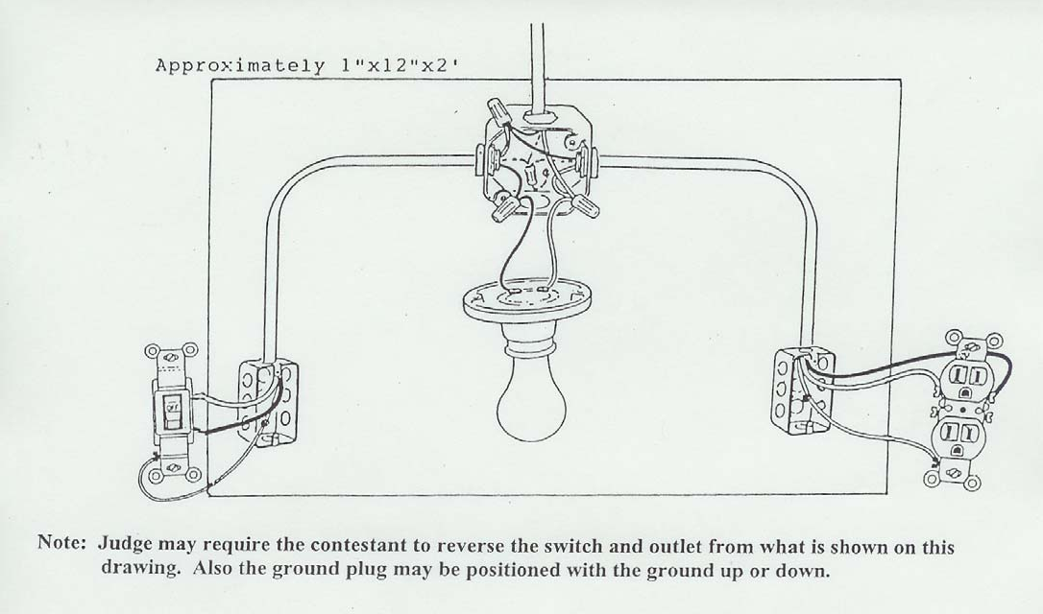

Note: Judge may require the contestant to reverse the switch and outlet from what is shown on this drawing. Also the ground plug may be positioned with the ground up or down.

THREE-WAY SWITCH ELECTRIC WIRING

- The three boxes shall be mounted with romex connectors already attached on a plain, unpainted, non- stained board, of any type wood, prior to contest according to diagram. (See drawing) Failure to follow the preceding rule will result in the contestant ranking being dropped one place.
- Boxes shall be surface mounted with screws.
- All wires shall be above the surface of the board.
- All boxes shall be grounded to the bare ground in the romex; twist wire around screw in receptacle box too. Ground wire in receptacle box should be secured in a horse shoe or half moon configuration.
- The three bare grounds in the octagon box shall be twisted together approximately one inch and connected with a crimp-type connector or green grounding wire nut with one ground wire connected to a machine-threaded screw. The ground wires shall be six to eight inches long including the approximately one inch twist.
- Keyless light fixture (plastic or porcelain) shall be connected to neutral and switch wire with No. 14 stranded or solid wire. Six inches to eight inches of free romex and insulated wire shall be left in box after connections are made, measured from point of entry.
- All romex must be clamped securely in the boxes.
- All splices, except the ground, shall be twisted together and must be fastened with proper size screw- on type connectors.
- When complete, all switches shall be fastened in boxes and covered with metal cover plates.
- Maximum time limit shall be 1 hour and 15 minutes.
- The contestant will not be penalized for bringing extra supplies.
- Safety glasses must be worn by the contestant. Failure to do so will result in lowering contestant one place.
- ¼” to ½” of romex is required inside the box; measured from the romex connector to the end of the romex.
- Eyelets should be made to wrap around the appropriate screw in a clockwise fashion.
- End of source wire will not be stripped and nothing will be attached to the source wire.
- After judge has made initial inspection, contestant will be asked to remove cover plates and unscrew fixtures from handy box.
- All wiring boards will be tested with an ohm meter for continuity.

SCORE CARD

- Tightness of connections 25 points

- Insulation (Covering all wires) 15 points

- Freedom from injury to wires in stripping, insulating, or twisting 35 points

- Adequate wire in boxes 15 points

- General neatness 10 points

- Contestants not completing exercise will be placed below those who finish the skill. EXAMPLE: See following page.

THREE-WAY SWITCH ELECTRIC WIRING (continued)

The following materials are necessary to complete the job: (the contestant will not be penalized for bringing extra supplies to the CDE.

  - Two surface-mount outlet boxes. (Sometimes called handy, utility, or conduit boxes)
  - One surface-mount 4” octagon outlet box 1 1/2” to 2” deep.
  - Two three-way switches with ground screw.
  - Six feet of 14-3 WG romex.
  - Two surface-mount metal switch covers.
  - One keyless light fixture (plastic or porcelain).
  - One 1-foot piece of unmarked and uncut 14-2 romex with No. 14 ground and two pieces of 8” long No. 14 wire.
  - Five 1/2” romex connectors.
  - Sufficient screws to mount boxes and a machine-threaded grounding screw.
  - One board 1” x 12” x 2’(approximately).
  - Screw-on type connectors of proper size.
  - Crimp-type connector.

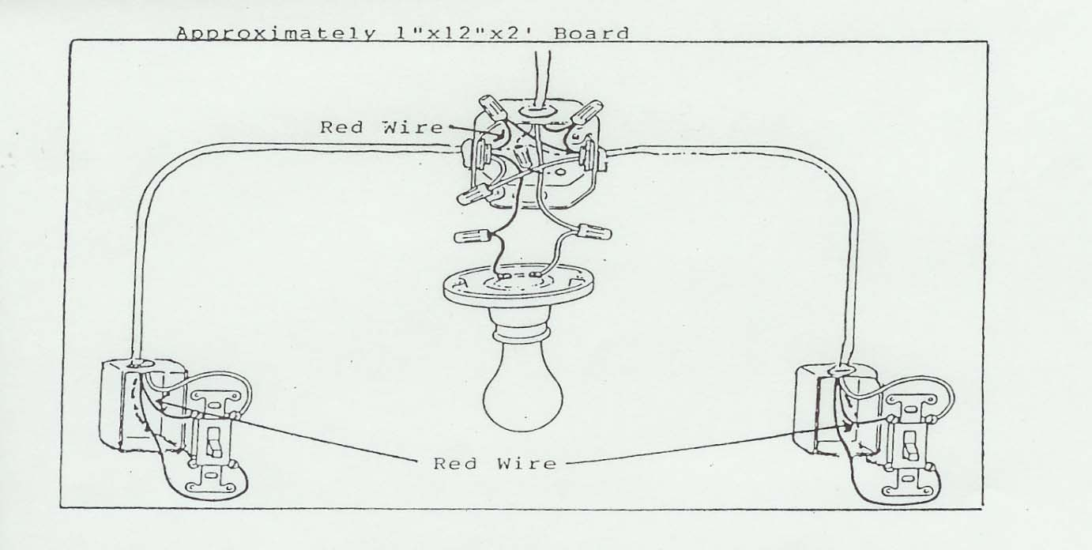

Note: Red wire to color-code Black and White Picture.

WIRE-FED WELDING

- Contestants will be required to use a 220 volt, gas welder. The wire will be .030 OR .035.
- Contestants will furnish all materials and equipment needed to complete skill:
  - Eight pieces of clean mild steel 1/8” at least 6” long and 1-2 inches wide will be used to run a butt weld and one of the following two welds, either a T weld or lap weld as determined by the judge.
  - Contestant shall bring his/her own practice metal if desired.
- Contestant will weld a 6” butt weld, welding full length on one side. See diagram on page 16 for lap and T weld.
- Metal used for welding may be cleaned and ground prior to CDE.
- T-weld must be welded in vertical position without the use of props or aids. (i.e.: chipping hammer, welding booth, extra metal pieces)
- No grinding permitted before or after welding: Jigs and clamps may not be used to position metal. No magnets to be used. No prior marks or lines may be drawn on the metal for aid in layout of the welds.
- No electric buffer - use chipping hammer and wire brush. The contestant must wear safety glasses or face shield (auto helmet).
- Take second two pieces of metal and repeat process.
- Turn in the best of the two welds.
- Time limit shall be one hour and 15 minutes. (15-minute practice and one hour for CDE)
- Only one pass will be permitted on each side.
- No clamps or jigs permitted. No magnets to be used.
- Safety glasses must be worn by the contestant. Failure to do so will result in lowering contestant one place.
- You are strongly encouraged to bring your own welder to the competition. This will take off pressure from the host chapter or other chapters who are bringing extra welders to the contest.
- Remember that penetration is vital in the game of life. The skills committee will cut metal and test for penetration each year, and that it is worth 20 out of the 100 points on the rubric.
REFERENCE: Mechanics in Agriculture by Phipps

 | SCORE CARD
1. Carrying out correct procedure above |  | 20 points
2. Smoothness and uniformity of welds |  | 50 points
3. Distortion |  | 15 points
4. Proper position | Total | 15 points  100 points*

Refer to Arc Welding butt weld diagram above.

Note: 75/25 mix gas will be provided. Please do not transport gas to CDE. No flux wire allowed. If you cannot provide your own welder, be prepared to borrow a welder on rotation.

LAND MEASURING (Will be removed after March 2022)

1. Four contestants shall measure and calculate to the nearest ten-thousandths (.0000) acre.
2. The official plot shall be laid out and measured by a qualified engineer or SCS technician prior to the CDE. (Request SCS technician to run problem twice – forward and backward).
3. Stakes, driven flush with the ground, shall be placed at all corners.
4. Plot shall be of the following specifications:
a. No plot shall be bigger than three acres
b. A five-sided figure with two adjacent right angles. Parallel sides may or may not be the same length. The inside angles on the opposite end of the parallel sides from the 90 degree ends shall be greater than 90 degrees.
c. Individuals laying out the plot shall use the smallest graduation on the tape and measure the plot to that graduation, i.e., 1/8 inch, 1/100 foot.
5. Contestants will use a 100’ or smaller tape to determine distances. The tape can be graduated in tenths or hundredths of a foot.
6. Square footage and calculations used in computing square footage will be turned in with the acreage answer. The contestant closest to the official square footage will be the winner. In the event two or more contestants submit identical acreage, the contestant closest to the official square footage will be the winner. Figures, formulas, and calculations of square footage will be checked by the judge in deciding ties.
7. Judges’ figures shall be posted after contest is completed.
8. Strings shall not be used as an aid in measuring.
9. Contestants may only use a non-programmable calculator.
10. Range poles are permitted and recommended as all stakes may not be visible from horizontal planes.
11. Be prepared for inclement weather
12. One hour and 15 minutes for measuring. Time will be flexible for calculations.

EXAMPLES: Marked angles must be right angles.

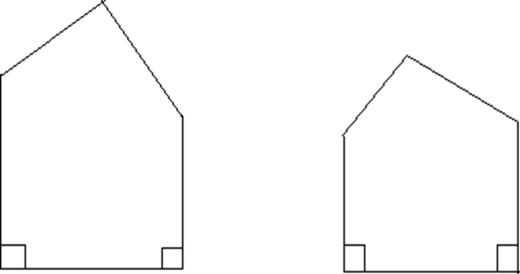

Needed materials:

1. 100’ tape
2. Clear clipboard
3. Non-programmable calculator
4. Range pole and plastic flags (optional)
5. Writing instrument

PROFILE LEVELING (BEGINNING 2024-2025 SCHOOL YEAR)

*** We will be looking at having a training for this event tentatively for Greenhand Conference Fall 2024.***
- Land Measuring will be removed permanently after the March 2022 contest at Haywood County High School.
- We (skills committee) are awaiting a meeting with Dr. Sandy Melhourn of UTM to set up the official rules and guidelines
- This will be a two-man event
- We are looking at a leveling field example, % fall example, filling pipe example, and running ditch example as some of the possibilities
- Non-programmable calculator.
- Hope to have this finalized and posted by the end of TAAE/Institute in July of 2024.

